[Saskatchewan Broomball Association]

Discipline and Complaints Policy


[May 7th, 2016]
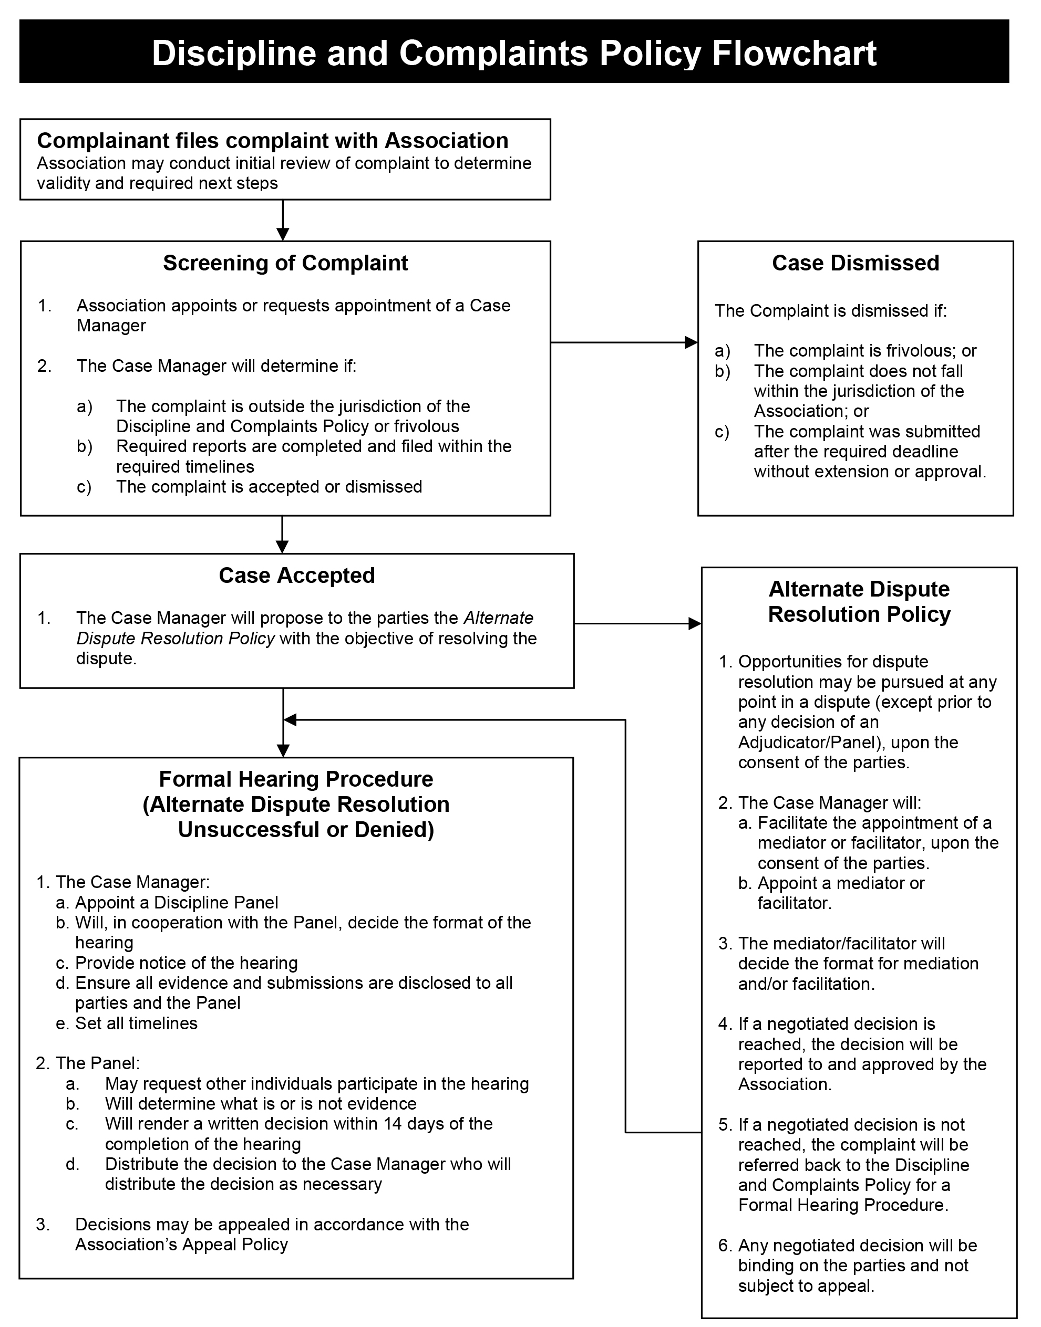
[Saskatchewan Broomball Association]
Discipline and Complaints Policy

Definitions
- The following terms have these meanings in this Policy:
  - “Association” – Saskatchewan Broomball Association
  - “Case Manager” – An individual appointed by the Association, who need not be a member or affiliated with the Association, to administer this Discipline and Complaints Policy. The Case Manager will comply with the position description described in Appendix “A”.
  - “Complainant” – The Party alleging an infraction
  - “Days” – Days including weekend and holidays
  - “Individuals” – All categories of membership defined in the Association’s Bylaws, including clubs, teams, as well as all individuals engaged in activities with the Association including, but not limited to, athletes, coaches, referees, officials, volunteers, managers, administrators, committee members, and directors and officers of the Association
  - “In writing”- A letter, fax or email sent directly to the Association.
  - “Respondent” – The alleged infracting Party

Purpose
- Individuals and participants are expected to fulfill certain responsibilities and obligations including, but not limited to, complying with Association’s policies, bylaws, rules and regulations, and Codes of Conduct. Non-compliance may result in sanctions pursuant to this Policy.

Application of this Policy
- This Policy applies to all Individuals relating to matters that may arise during the course of Association’s business, activities, and events including, but not limited to, competitions, practices, tryouts, training camps, travel associated with Association activities, and any meetings.

- This Policies also applies to Individuals’ conduct outside of the Association’s business, activities, and events when such conduct adversely affects relationships within the Association (its work and/or sport environment) or is detrimental to the image and reputation of the Association. The jurisdiction of this Policy will be determined by the Association at its sole discretion.

- This Policy does not prevent discipline from being applied, during a competition or event. Further discipline may be applied according to this Policy. Any infractions or complaints occurring within competition will be dealt with by the procedures specific to the competition, if applicable. In such situations, disciplinary sanctions will be for the duration of the competition, training, activity or event only.

- An employee of the Association found to have to be a Respondent will be subject to appropriate disciplinary action subject to the terms of the Association’s Human Resources Policy, as well as the employee’s Employment Agreement, as applicable. Violations may result in a warning, reprimand, restrictions, suspension or other disciplinary actions up to and including termination of employment.

Reporting a Complaint
- Any Individual may report any complaint to the Association. A complaint must be In Writing and must be filed within 21 days of the alleged incident. Complaints should be submitted to:

Stacey Silzer – Executive Director
2205 Victoria Ave, Regina, SK S4P 0S4
Email: saskbroomball@sasktel.net
Fax: 306-525-4009 (Attention: Broomball)

- A Complainant wishing to file a complaint outside of the 21 days must provide a written statement giving reasons for an exemption to this limitation. The decision to accept or deny the complaint outside of the 21 days will be at the sole discretion of the Case Manager. This decision may not be appealed.

- At the Association’s discretion, the Association may act as the complainant and initiate the complaint process under the terms of this Policy. In such cases, the Association will identify an individual to represent the Association.

- Resignation or lapsing of membership after a complaint is filed does not preclude disciplinary proceedings being pursued under this policy.

- Upon receiving a complaint, the Association will review the complaint to determine validity and required next steps.
Case Manager
- Upon the receipt and review of a complaint, the Association may appoint or request the appointment of an independent Case Manager to manage and administer complaints submitted in accordance with this Policy and such appointment is not appealable. Case Manager services will be accessible through Sask Sport from an external firm or pool of individuals with knowledge and expertise in dispute resolution.

- The Case Manager has a responsibility to:
  - Determine whether the complaint is within the jurisdiction of this Policy or frivolous
  - Propose the use of the Association’s Alternate Dispute Resolution Policy
  - Appoint the Discipline Panel, if necessary
  - Coordinate all administrative aspects and set timelines
  - Provide administrative assistance and logistical support to the Panel as required
  - Provide any other service or support that may be necessary to ensure a fair and timely proceeding.

Procedures
- If the Case Manager determines the complaint is:
  - Frivolous or outside the jurisdiction of this Policy, the complaint will be dismissed immediately.
  - Not frivolous and within the jurisdiction of this Policy, the Case Manager will notify the Parties the complaint is accepted and the applicable next steps.

- The Case Manager’s decision to accept or dismiss the complaint may not be appealed.

- The Case Manager will establish and adhere to timeframes that ensure procedural fairness and that the matter is heard in a timely fashion.

- After notifying the Parties that the complaint has been accepted, the Case Manager will first, propose the Association’s Alternate Dispute Resolution Policy with the objective of resolving the dispute. If the dispute is not resolved or the parties refuse the Alternate Dispute Resolution Policy, the Case Manager will appoint a Discipline Panel, which shall consist of a single Adjudicator, to hear the complaint. In extraordinary circumstances, and at the discretion of the Case Manager, a Panel of three persons may be appointed to hear the complaint. In this event, the Case Manager will appoint one of the Panel’s members to serve as the Chair.

- The Case Manager, in cooperation with the Discipline Panel, will then decide the format under which the complaint will be heard. This decision may not be appealed. The format of the hearing, which may involve direct communications with the Parties, an oral in-person hearing, an oral hearing by telephone or other telecommunications, a hearing based on a review of documentary evidence submitted in advance of the hearing, or a combination of these methods. The hearing will be governed by the procedures that the Case Manager and the Discipline Panel deem appropriate in the circumstances, provided that:
- The Parties will be given appropriate notice of the day, time, and place of the hearing, in the case of an oral in-person hearing, an oral hearing by telephone or other telecommunications
- Copies of any written documents which the parties wish to have the Panel consider will be provided to all Parties, through the Case Manager, in advance of the hearing and/or decision rendered
- The Parties may be accompanied by a representative, advisor, or legal counsel at their own expense
- The Discipline Panel may request that any other individual participate and give evidence at the hearing
- The Discipline Panel may allow as evidence at the hearing any oral evidence and document or thing relevant to the subject matter of the complaint, but may exclude such evidence that is unduly repetitious and shall place such weight on the evidence as it deems appropriate
- The decision will be by a majority vote of the Discipline Panel

- If the Respondent acknowledges the facts of the incident, the Respondent may waive the hearing, in which case the Discipline Panel will determine the appropriate disciplinary sanction. The Discipline Panel may still hold a hearing for the purpose of determining an appropriate sanction.

- The hearing will proceed in any event, even if a Party chooses not to participate in the hearing.

- If a decision affects a 3rd party to the extent that the 3rd party would have recourse to a complaint or an appeal in their own right, that 3rd party will become a party and apart of the complaint procedure to the complaint in question and will be bound by the decision.

- In fulfilling its duties, the Panel may obtain independent advice.

Decision
- After hearing and/or reviewing the matter, the Discipline Panel will determine whether an infraction has occurred and, if so, the sanctions to be imposed. Within fourteen (14) days of the hearing’s conclusion, the Discipline Panel's written decision, with reasons, will be distributed to all Parties, the Case Manager, and the Association. In extraordinary circumstances, the Discipline Panel may first issue a verbal or summary decision soon after the hearing’s conclusion, with the full written decision to be issued before the end of the fourteen (14) day period. The decision will be considered a matter of public record unless decided otherwise by the Discipline Panel.

Sanctions
- The Panel may apply the following disciplinary sanctions, singularly or in combination:
- Verbal or written reprimand
- Verbal or written apology
- Service or other contribution to the Association
- Removal of certain privileges
- Suspension from certain teams, events, and/or activities
- Suspension from all Association activities for a designated period of time
- Withholding of prize money or awards
- Payment of the cost of repairs for property damage
- Suspension of funding from the Association or from other sources
- Expulsion from the Association
- Any other sanction considered appropriate for the offense

- Unless the Discipline Panel decides otherwise, any disciplinary sanctions will begin immediately, notwithstanding an appeal. Failure to comply with a sanction as determined by the Discipline Panel will result in automatic suspension until such time as compliance occurs.
- Infractions that result in discipline will be recorded and records will be maintained by the Association.

Suspension Pending a Hearing
- The Association may determine that an alleged incident is of such seriousness as to warrant suspension of an Individual pending completion of the criminal process, a hearing or a decision of the Panel.

Criminal Convictions
- An Individual’s conviction for a Criminal Code offense, as determined by the Association, will be deemed an infraction under this Policy and will result in expulsion from the Association. Criminal Code offences may include, but are not limited to:
  - Any child pornography offences
  - Any sexual offences
  - Any offence of physical violence
  - Any offence of assault
  - Any offence involving trafficking of illegal drugs

Confidentiality
- The discipline and complaints process is confidential and involves only the Parties, the Case Manager, the Discipline Panel, and any independent advisors to the Panel. Once initiated and until a decision is released, none of the Parties will disclose confidential information relating to the discipline or complaint to any person not involved in the proceedings.

Timelines
- If the circumstances of the complaint are such that adhering to the timelines outlined by this Policy will not allow a timely resolution to the complaint, the Discipline Panel may direct that these timelines be revised.

Records and Distribution of Decisions
- Other individuals or organizations, including but not limited to, national sport organizations, provincial sport organizations, Sask Sport Inc., etc., may be advised of any decisions rendered in accordance with this Policy.

Appeals Procedure
- The decision of the Panel may be appealed in accordance with the Association’s Appeal Policy.

Appendix A

CASE MANAGER POSITION DESCRIPTION
Purpose
    - In some of its policies, the Association requires the appointment of a Case Manager. This Position Description outlines the role, identity, responsibilities and tasks of the Case Manager.

Policies
- The following Policies require the appointment of a Case Manager:
- Discipline and Complaints
- Appeal
- Alternate Dispute Resolution Policy

Identity
- The Case Manager, whether or not appointed by the Association at its sole discretion, should be experienced with the management of disputes in an unbiased manner. The individual should not be connected in any way to the issue being disputed (and/or the outcome of the dispute) but does not necessarily need to be an independent third-party not connected with the Association – though the guaranteed independence and neutrality of a third-party is preferred. The individual does not need to be a Member of the Association.

- The Case Manager’s identity does not need to be approved by any of the parties involved in the dispute, excluding the Association.

Discretion - Complaints
- When a complaint is filed, the Case Manager is required to:
  - Determine whether the complaint is frivolous and within the jurisdiction of the Discipline and Complaints Policy
  - Propose the use of the Association’s Alternate Dispute Resolution Policy
  - Appoint the Panel, if necessary
  - Coordinate all administrative aspects and set timelines
  - Provide administrative assistance and logistical support to the Panel as required
  - Provide any other service or support that may be necessary to ensure a fair and timely proceeding

Discretion - Appeals
- When an appeal is filed, the Case Manager is required to:
- Propose the use of the Association’s Alternate Dispute Resolution Policy
- Determine if the appeal falls under the scope of the Appeal Policy
- Determine if the appeal was submitted in a timely manner
- Decide whether there are sufficient grounds for the appeal
- Appoint the Panel, if necessary
- Coordinate all administrative aspects and set timelines
- Provide administrative assistance and logistical support to the Panel as required
- Provide any other service or support that may be necessary to ensure a fair and timely proceeding

- When determining if there are sufficient grounds for appeal, the Case Manager is not acting as the Panel and determining the merits of the appeal, but instead determining whether the Appellant has properly shown that an error, as described in the Appeal Policy, has been properly argued. The Case Manager will need to carefully consult the Association’s policies and procedures, and analyze the process that contributed to the decision, to determine whether there are appropriate grounds.

Discretion – Alternate Dispute Resolution
- When the parties agree to the jurisdiction of the Alternate Dispute Resolution Policy, the Case Manager maybe required to:
- Appoint the mediator or facilitator
- Coordinate all administrative aspects and set timelines
- Provide administrative assistance and logistical support to the mediator or facilitator as required

Hearing Format - Discretion
- If necessary, the Case Manager is required to exercise their discretion to determine the format of the hearing. Hearings typically take the following forms, but are not limited to:
- In person
- Conference call
- Written submissions
- Conference call plus written submissions

- In determining the format of the hearing the Case Manager should consider:
- The distance between the parties
- The animosity between the parties
- The time commitment and location of the Panel
- The timelines for a decision
- The language barriers between the parties
- The gravity of the complaint/appeal

Panel Appointment
- The Case Manager is required to appoint a Panel of one person, or three in extraordinary circumstances, to decide the issue. The individual(s) should have the following characteristics:
- Experience in dispute resolution
- Experience with sport disputes
- No connection to either party
- Preferably no connection with the Parties
- Decisive

- The Case Manager should remind the Panel to adhere to the powers given to the Panel by the applicable policy. For example, if the policy does not permit the Panel to suspend the respondent indefinitely, then the Panel cannot sanction the respondent in this manner.

Communication
- Especially when the hearing is to be held by written submissions, the Case Manager is required to communicate swiftly, clearly, and decisively with each party. The parties must adhere to the deadlines set by the Case Manager or by the applicable policy and the process must move forward even if a party misses a deadline.

- When coordinating an oral hearing, the Case Manager should first consider the schedule of the Panel, then the schedule of the complainant, and then the schedule of the respondent in an attempt to find a suitable time for everyone.

Suggested Procedure
- The Case Manager may implement the following procedure to facilitate the Discipline and Complaints Policy or the Appeal Policy:
  - Receive the written complaint or appeal
  - Communicate with the Complainant/Appellant that you have been appointed the Case Manager and that their complaint/appeal will be disclosed to the Respondent and Panel. Also determine if there is additional evidence or written submissions to follow, if so, provide a deadline for receipt. (After this step, the Complainant/Appellant may not have another opportunity to make additional submissions or provide evidence, unless determined otherwise by the Panel)
  - Determine whether the complaint is within the jurisdiction of the applicable Policy.
  - Notify the Respondent that you are the Case Manager and are in receipt of a complaint/appeal. Communicate to the Respondent that any submissions will be provided to the Complainant/Appellant and Panel. Provide the Respondent with a reasonable timeframe to submit their response document and any applicable evidence. (After this step, the Respondent may not have another opportunity to make additional submissions or provide evidence, unless determined otherwise by the Panel).
  - The Case Manager may wish to provide the Complainant/Appellant to submit a rebuttal, but the rebuttal must be limited to issues raised by the Respondent and is not an opportunity to provide new evidence. The Panel may exclude such new evidence.
  - Appoint the Panel
  - Conduct a hearing either via written documentation, teleconference, in – person, or a combination of these techniques.
  - Ensure the Panel renders a written decision within a prescribed timeline.

